Desde Raspbian:

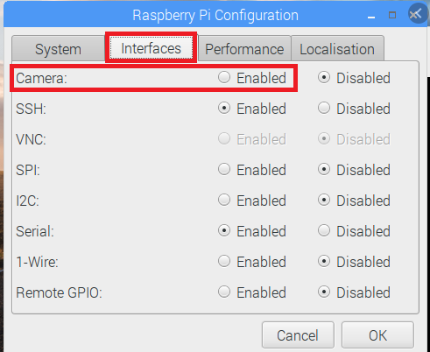

Conecte camara

reboot

From the command line, run the following:

raspivid -o test.h264 -t 10000

This will record ten seconds of video to your microSD card.

If you have an HDMI cable plugged in, you’ll see what the camera can see in real-time.

**OTRA ALTERNATIVA**

sudo apt update

sudo apt full-upgrade

sudo raspi-config

Use the cursor keys to select and open *Interfacing Options*, and then select *Camera* and follow the prompt to enable the camera.

Upon exiting raspi-config, it will ask to reboot.

= = =

TEST

To install a USB web cam

sudo apt install fswebcam

Add user pi

sudo usermod -a -G video pi

Enter the command fswebcam followed by a filename and a picture will be taken using the webcam, and saved to the filename specified:

fswebcam image.jpg

Specific resolution

fswebcam -r 1280x720 image2.jpg

no banner

fswebcam -r 1280x720 --no-banner image3.jpg

You can write a Bash script which takes a picture with the webcam. The script below saves the images in the /home/pi/webcam directory, so create the webcam subdirectory first with:

mkdir webcam

To create a script, open up your editor of choice and write the following example code:

**#!/bin/bash**

DATE=$(date +"%Y-%m-%d_%H%M")

fswebcam -r 1280x720 --no-banner /home/pi/webcam/$DATE.jpg

This script will take a picture and name the file with a timestamp. Say we saved it as webcam.sh, we would first make the file executable:

chmod +x webcam.sh

Then run with:

./webcam.sh

## Time-lapse using cron

You can use cron to schedule taking a picture at a given interval, such as every minute to capture a time-lapse.

First open the cron table for editing:

crontab -e

This will either ask which editor you would like to use, or open in your default editor.

Once you have the file open in an editor, add the following line to schedule taking a picture every minute (referring to the Bash script from above):

* * * * * /home/pi/webcam.sh **2**>**&1**

Save and exit and you should see the message:

crontab: installing new crontab

Ensure your script does not save each picture taken with the same filename. This will overwrite the picture each time.

## Other Useful tools

Other tools are available that may come in handy when using the camera or a webcam:

* [SSH](https://www.raspberrypi.org/documentation/remote-access/ssh/README.md)
  + Use SSH to remotely access the Raspberry Pi over your local network
* [SCP](https://www.raspberrypi.org/documentation/remote-access/ssh/scp.md)
  + Copy files over SSH to get copies of pictures taken on the Pi on your main computer
* [rsync](https://www.raspberrypi.org/documentation/remote-access/ssh/rsync.md)
  + Use rsync to synchronise the folder of pictures taken in a folder between your Pi to your computer
* [cron](https://www.raspberrypi.org/documentation/linux/usage/cron.md)
  + Use cron to schedule taking a picture at a given interval, such as every minute to capture a time-lapse